DSA 0601 - Data handling and visualization
Set 17 - Employee Performance Analysis

Name : B.Jahnavi
Reg.no:192325043

- Line Chart of Employee Performance
Code:

library(ggplot2)

employees <- data.frame(
Employee_ID = c(1, 2, 3),
Department = c("Sales", "HR", "Marketing"),
Years_of_Service = c(5, 3, 7),
Performance_Score = c(85, 92, 78)
)

ggplot(
employees,
aes(x = Years_of_Service, y = Performance_Score)
) +
geom_line() +
geom_point(size = 3) +
labs(
title = "Employee Performance by Years of Service",
x = "Years of Service",
y = "Performance Score"
) +
theme_minimal()

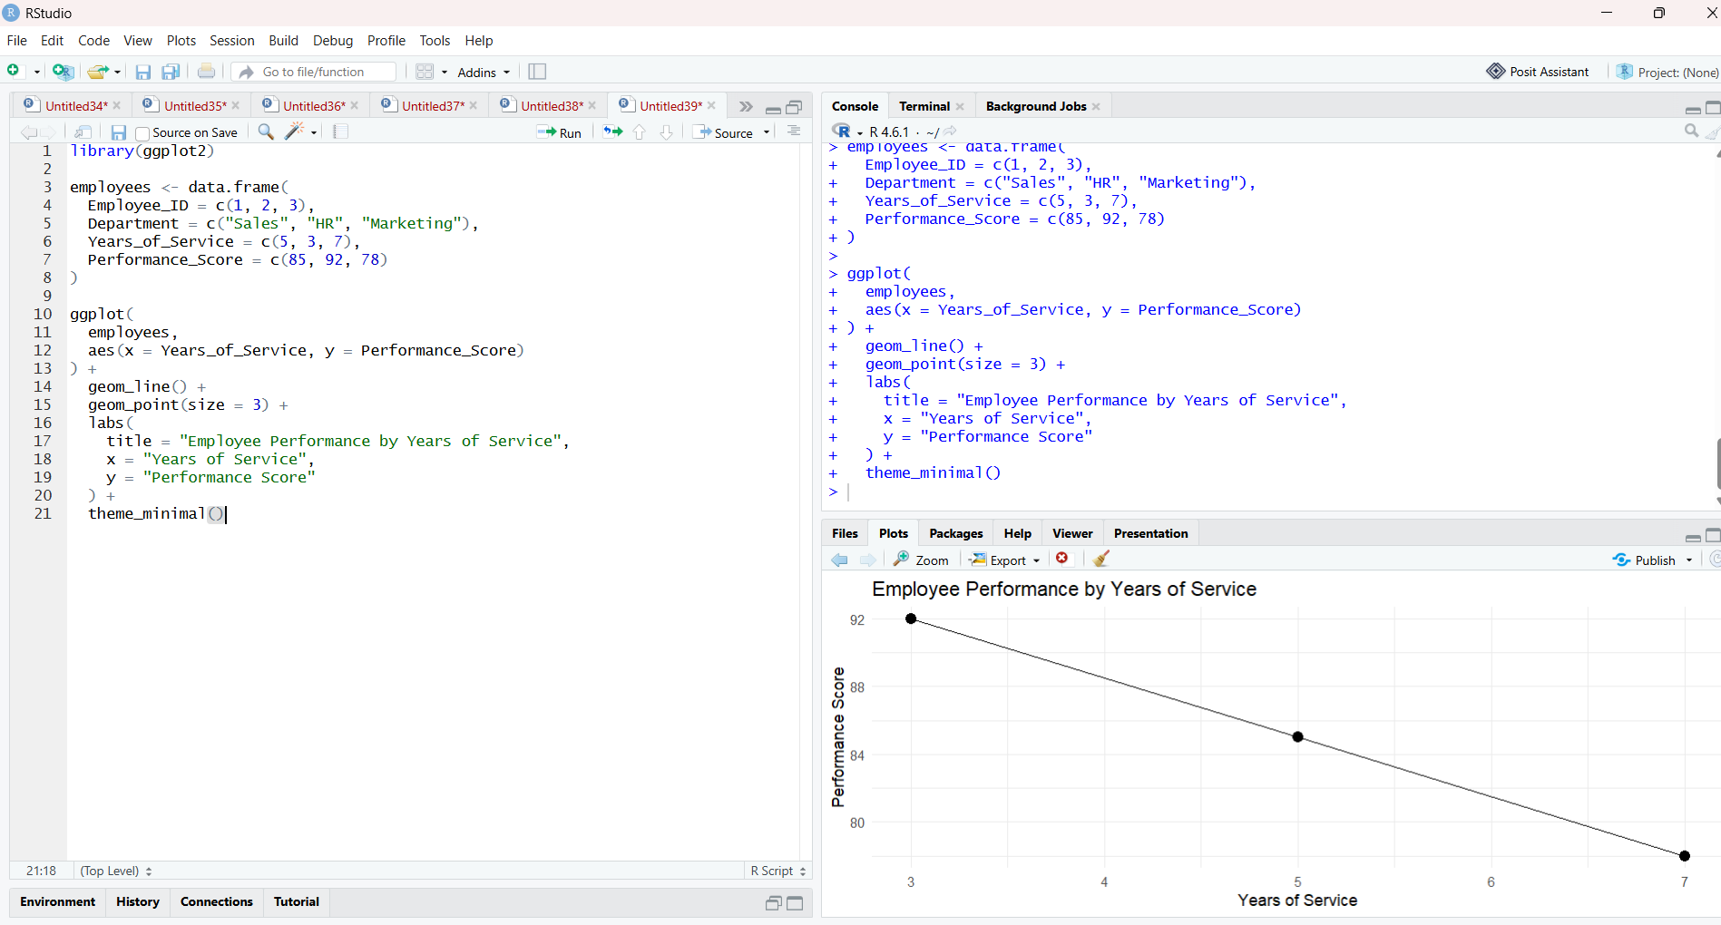

- Bar Chart of Employees by Department
Code:

library(ggplot2)

employees <- data.frame(
Employee_ID = c(1, 2, 3),
Department = c("Sales", "HR", "Marketing"),
Years_of_Service = c(5, 3, 7),
Performance_Score = c(85, 92, 78)
)

ggplot(employees, aes(x = Department)) +
geom_bar() +
labs(
title = "Number of Employees by Department",
x = "Department",
y = "Number of Employees"
) +
theme_minimal()

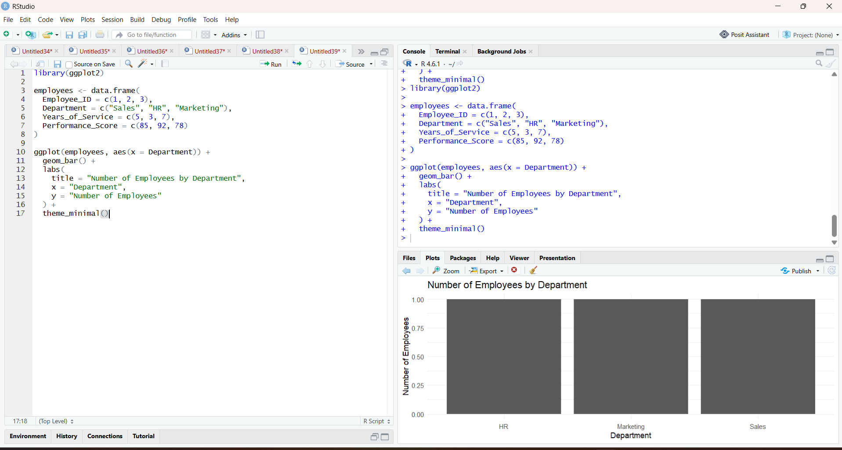

3. Table of Employee Performance
Code:

employees <- data.frame(
Employee_ID = c(1, 2, 3),
Department = c("Sales", "HR", "Marketing"),
Years_of_Service = c(5, 3, 7),
Performance_Score = c(85, 92, 78)
)

print(employees)

library(knitr)

kable(
employees,
caption = "Employee Performance Data",
col.names = c(
"Employee ID",
"Department",
"Years of Service",
"Performance Score"
)
)
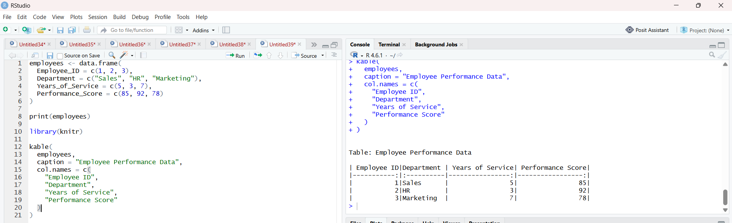

4. Prepare Data for Tableau Dashboard
Code:

employees <- data.frame(
Employee_ID = c(1, 2, 3),
Department = c("Sales", "HR", "Marketing"),
Years_of_Service = c(5, 3, 7),
Performance_Score = c(85, 92, 78)
)

write.csv(employees, "employee_performance.csv", row.names = FALSE)

print("CSV file created successfully.")

